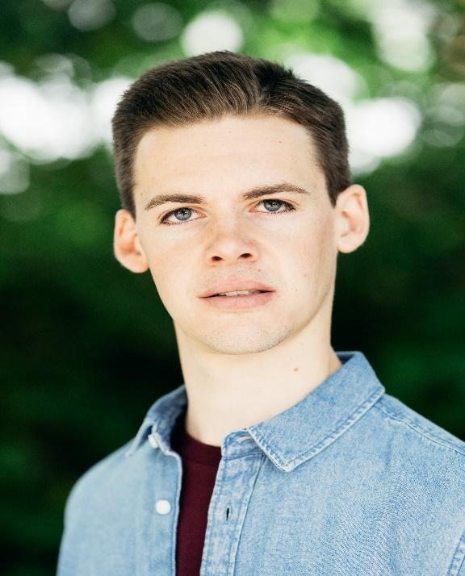
Harry Whittaker
Email: harry.whittaker95@gmail.com Location: Luton, United Kingdom
Nationality: British Height: 6’1” (185cm) Playing Age: 16 -25
Appearance: Caucasian Hair Colour: Brown Eyes: Blue
Voice Quality: Gentle Voice Character: Friendly Other: Equity, DBS Checked

TRAINING AND AWARDS
2016 - In Progress: University of Bedfordshire BA Theatre and Professional Practise.
2018 - Nominated for Equity Student Bursary Scheme
2018 - Awarded Steel Charitable Trust Bursary

FILM/SHORT FILM
2018 Funeral Attendee OATS AND BARLEY Knucklehead 2018 Perpetrator CRIME RESEARCH SHORT FILM University of Bedfordshire
TELEVISION
2018 Pedalo Youth TOP BOY Netflix/Wellstreet Productions 2018 Mickey Dolenz AUTOPSY: THE LAST HOURS OF.. ITV Studios/Potato TV 2018 Office Assistant GOMORAH Cattleya/Sky Atlantic
COMMERCIAL
2018 Science Student STEM CINEMA ADVERT iClearhead 2018 Shop customer BBC SOUNDS iBBC 2018 Train passenger EUROSTAR IBeyond Studio 2018 Bartender GRACE MUSIC VIDEO Virgin Records 2018 Pool Party Guest CAPRICORN MUSIC VIDEO IWarner Music UK 2017 Business student REALISE YOUR POTENTIAL IClearhead 2017 Student PERFORMING ARTS IiUniversity of Bedfordshire
STAGE
2018 Harry POP (SCALL SCALE TOUR) Devised 2018 Pike DAD’S ARMY ISt Augustine’s Players 2018 Keith CASSIE iUniversity of Bedfordshire 2018 Hank THE TIN WOMAN IIUniversity of Bedfordshire 2018 Guard SMILE IIUniversity of Bedfordshire 2018 Harry iDEAL WITH IT IIUniversity of Bedfordshire 2017 Ensemble AFTERLIVES iMkultra 2017 Thomas HEAR iUniversity of Bedfordshire 2017 Alex LACES I University of Bedfordshire
2017 Simon ROUTINE University of Bedfordshire 2017 Peter ON THE SHORE OF THE WIDE WORLD IUniversity of Bedfordshire 2016 Adam THE GENESIS GAMES IUniversity of Bedfordshire 2013 Herr Schultz CABARET ISteve Crayon 2012 Beadle Bamford SWEENEY TODD IISteve Crayon 2012 Steve iDECADENCE IiILuton Sixth Form 2011 Iago OTHELLO iShakespeare Festival

SKILLS

Accents and Dialects: Lutonian*, RP, Mancunian, Scouse, London (* = native)
Music: Grade 2 Piano, Choral singing training
Sports: Football, Qualified Football Coach, Tennis, Swimming, Cricket, Running, Badminton
Other: Devising, Drama workshop leader, Artistic director, Writer, Collaborator

